T H E C W L V O I C E


A Friendly Note from the CWL Council of St. Anne’s Parish, Osoyoos, BC
Vol.15 number 03 President: Elaine Middleton – Phone: 250-495-6186 March 15, 2015

Next CWL General Meeting…

This Thursday, March 19, 2015,
following the 9:00 a.m

Join us for the CWL Officer Installations and Awarding of Service Pins

Even if you cannot make the meeting
Please, come pray with us at morning Mass

Coffee, Tea and Light refreshments

Visitors and new members welcome

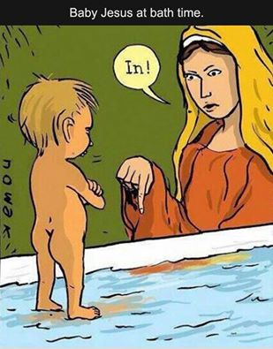
Sincere condolences to Phil Petrie and his extended family on the passing of his wife, Margaret.
A reminder to all CWL members attending her funeral on Tuesday, March 17, at 11 am to please pick up a CWL scarf at the back of the Church and join us in her Honour Guard.

Important Message …
Dear CWL sisters and ladies of the parish,

Thinking back over 2014, the first year of our two years as your executive, we reflect upon the many positive things for which we are grateful: The Christmas Tea and the Fashion show, helping with other Church activities like teas for 1st Communicants, those being Confirmed and funeral receptions etc. It is our joy to be such a vital support organization for our parish.
However, I’d also like to mention some concerns your Executive has for the future of our CWL Council here at St. Anne’s.
Our average age puts most of us as “Seniors”. Although we receive much help for our many projects we will soon need new leaders to relieve our tired ones.
Evidently filling executive positions has been a problem for quite a few years. Most of our long time members have filled more than one office multiple years.
They are growing tired.
We sincerely appreciate all the support from both members and non-members in the past. We are praying for new ladies to seriously consider taking over some of the positions.
Secondly, we ask that some of the younger ladies in our parish support us and join our group.
With slightly less than a year to go before it is time to find a new slate of executive offices it is time to pray for guidance in discerning what part we can each play in filling the seats available in Jan. 2016. We cannot always count on ‘someone else.’ No executive, no council.
Highlights from current
CWL of Canada Constitution & Bylaws…

During 2015 The CWL Voice are featuring the roles of Parish Council officers and Standing Committee Chairpersons. This month we begin with: Spiritual Development and Oganization committees.
In order for the council to function at its best, all roles need to be filled.

Spiritual Development
- Spiritual growth of members
- Study of Catholic teachings
- Role of women in the church
- Evangelization and mission assistance
- Lay ministries
- Ecumenism and interfaith endeavours

Organization
- Recruit members and maintain membership
- Leadership development
- League resource material
- Annual reports
- Life membership

Although the above are directly quoted from our latest Constitution & Bylaws of 2013, our Council here at St. Anne’s refers to officer roles more as a suggested guideline than as absolute law. We stylize more to suit our needs and preferences.
We do, however, try to follow policy and procedures as close to as written as possible.
We are a friendly group who attempts to keeps things as relaxed and workable as possible.

Next Month The CWL Voice will feature the Standing Committees of Christian Family Life and Community Life.

ComingEvents
- Father Dave’s 45th Anniversary of Ordination to the Priesthood … April 26th, 2015.
- CWL Ladies Fun Night/Wrap up dinner- sometime in mid-June. The Exact date, time and venue will be decided, with your help at an upcoming meeting.

Editor The CWL Voice: Elaine Middleton
Have an idea for the next newsletter?
Phone 495-6186 or send e-mail to elaine.middleton@telus.net
Please Plan to Attend…
2015 CWL Conventions

Nelson Diocesan 79th Annual Convention - Trail, BC
Apr. 30, May 1st and 2nd
Registration deadline - April 13
BC & Yukon Provincial Convention–Prince George, BC
Thurs., June 11th to Sat., June 13
Registration deadline – May 10th
2015 CWL National Convention – Vancouver
Sun., Aug. 16th to Wed., Aug. 19th
Registration deadline – July 15th
For more information contact Elaine Middleton
Phone: 250 – 495 – 6186
Or email: elaine.middleton.net

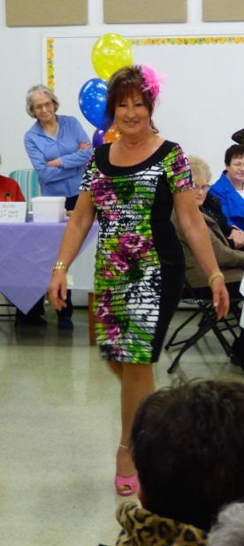
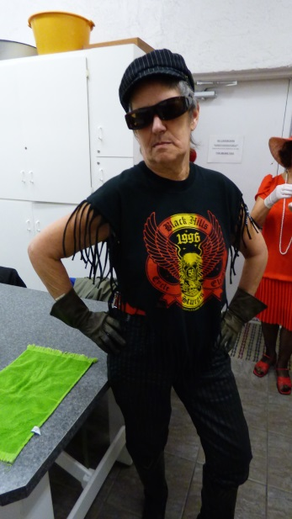

What to wear What not to wear

Fashion Show Huge Success Again…

Attendants included a large number of snowbirds, our mayor & an 80 year old previous CWL president from St. Anne's who enjoyed an afternoon of fun & fashion. Our thanks to Sonia Lopez for again supporting our annual Fashion show.

Very humorous entertainment was provided by the Goat Ladies, featuring fashions advising us what NOT to wear…anywhere. Thanks Ron Stevens for emceeing this portion.

Special thanks to the Fashion show committee headed by Judi Whitehouse and catered by Vi Kovaks and her team and all who stepped in to help them. A BIG THANKS to the winner of the 50/50 draw ($141) from Manitoba who donated her winnings back to the CWL.

